James Joyce

**Thumbnail Definition:**

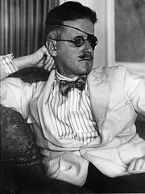

*James Joyce.*

(via Creative Commons <http://www.flickr.com/photos/info_grrl/5790528163/>)

James Joyce (2 February 1882 – 13 January 1941) was an Irish modernist author famous for his experimentalism and for writing about Dublin. All of his major works – from the short stories of *Dubliners* (1914), through the ironic bildungsroman *A Portrait of the Artist as a Young Man* (1916) and the encyclopaedic *Ulysses* (1922), to the linguistic play of *Finnegans Wake* (1939) – are set in and around Dublin, filled with real people and incidents from Joyce’s life in that city. This does not mean that Joyce’s relationship with Dublin is uncomplicated – he lived in self-imposed exile in Europe for most of his life and early in his career identified the city as a ‘centre of paralysis’ (*Letters*, I, 1966 55). Further, although Joyce’s books were not formally banned in Ireland, his work was widely disapproved of and neglected. The Bloomsday celebration, which re-enacts events from *Ulysses*, is a fairly recent phenomenon, pioneered in 1954, and only becoming a big event decades later. Joyce explained his use of Dublin to his friend as, crucially, a question of *technique*, by saying that ‘If I can get to the heart of Dublin I can get to the heart of all the cities of the world’ (Ellmann, 1982, 505).

**Main Entry:**

Although Joyce is most famous as a novelist, his work is more diverse than we might expect: he also produced poems, a play and occasional journalism, though these are very much minor works. Even with major works, we might say that Joyce never repeats himself – he wrote short stories (*Dubliners*), then a fairly conventional novel (*Portrait*), followed by an extremely experimental novel (*Ulysses*), and finally a text which goes far beyond the boundaries of the novel (the *Wake*). We also possess the published manuscripts of unfinished projects – Stephen Hero (an early draft of *Portrait*) and *Giacomo Joyce* (a prose poetry erotic confession). Key Joycean representational techniques include the stream of consciousness technique, the use of dashes instead of quotation marks, multiple styles in a single work, intertextuality, pastiche and parody, irony, puns and portmanteau.

Joyce had strong friendships with other modernist authors, especially with the poet Ezra Pound, who first championed his work.

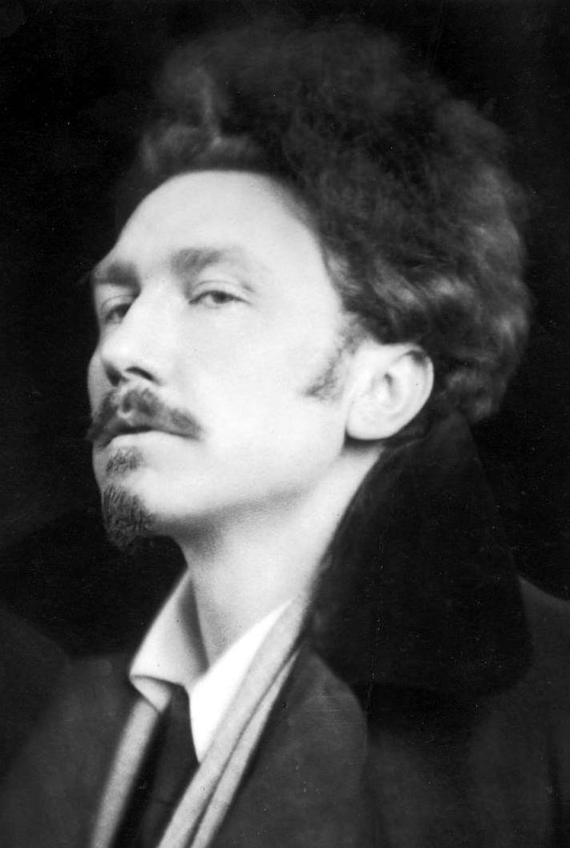

*Ezra Pound*

(Via CC <http://commons.wikimedia.org/wiki/File:Ezra_Pound_by_E.O._Hoppé_in_1920_(LIFE2).JPG>)

Pound saw to it that Joyce’s work was serially published in modernist periodicals such as the *Egoist* and *The Little Review* and arranged reviews. Pound also introduced Joyce to Harriet Shaw Weaver and Sylvia Beach, who would become his patron and publisher respectively. Pound saw that Joyce’s position would be improved by a move from Trieste, where he had taught on and off as an English teacher since his departure from Ireland with his wife Nora in 1904, to Paris. As a result of this, Joyce moved from the margins to the centre of the modernist avant-garde. Despite problems with his eyesight and with American censorship, which in 1921 banned the serial publication of *Ulysses* in *The Little Review*, Joyce’s masterpiece was eventually published in 1922 by Sylvia Beach at her Paris bookshop, Shakespeare and Company. Joyce was deeply involved in the publishing process, for example choosing the distinctive blue-green cover:

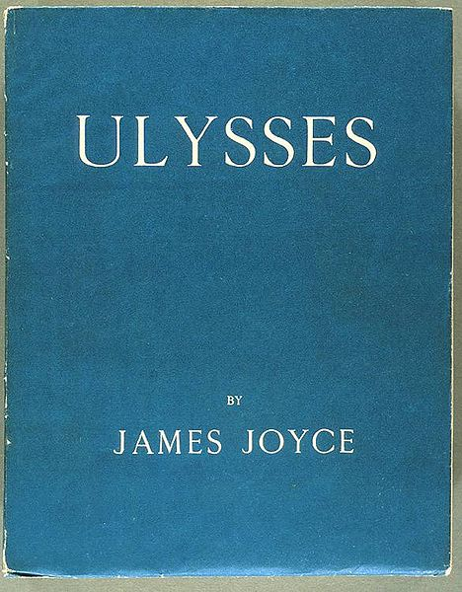

(Via CC <http://commons.wikimedia.org/wiki/File:JoyceUlysses2.jpg>)

Joyce also worked to generate publicity for the book through readings at Shakespeare and Company. Here is a clip of Joyce reading from the ‘Aeolus’ episode:

<http://archive.org/details/JamesJoyce1924ReadingFromUlyssses>

(Internet Archive, Public Domain)

The early reception of Joyce’s work was guided by Ezra Pound and other admirers. However, after *Ulysses*, driven partly by Pound’s lack of support for the linguistically experimental anti-novel *Finnegans Wake*, Joyce began to take the management of his reputation into his own hands. For example, the first critical studies of *Ulysses* came from Joyce’s friends, under his direction; Herbert Gorman wrote a 1924 critical study *James Joyce: The First Forty Years*, followed by a biography, Frank Budgen produced *James Joyce and the Making of Ulysses* (1934), Stuart Gilbert produced *James Joyce’s Ulysses: A Study* (1930), using a schema which Joyce gave him of its structures, especially the Homeric parallels. So begins the ‘Joyce industry’. And these works did succeed in setting the tone for readers and critics of Joyce far beyond his early death from a perforated ulcer in 1941 – the emphasis on myth, history and structure, rather than personal or political aspects of Joyce, made his work safe for 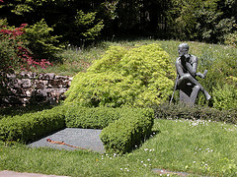New Criticism and ensured its canonicity.

*Joyce’s grave in Zurich*

( Via CC <http://www.flickr.com/photos/robert_scarth/2271603826/>)

In fact, this impersonal, mythic, universal Joyce was slow to shift even after New Criticism: a turning point was perhaps Ellmann’s 1959 biography and the release of editions of Joyce’s letters and the manuscript of *Giacomo Joyce* during the 1960s. These texts offered readers a different version of Joyce. Post-structuralist theory then left a deep imprint through Derek Attridge’s and Daniel Ferrer’s edited *Post-Structuralist Joyce*. Similarly, the advent of postcolonial theory also offered a chance for a re-Irishing and re-politicising of Joyce’s work. Emer Nolan’s *James Joyce and Nationalism*, Keith Booker’s *Ulysses, Capitalism and Colonialism* and Attridge’s and Howes’s collection of essays, *Semicolonial Joyce*, allow us to take Joyce’s politics as seriously as his history. A further trend in Joyce Studies is genetic criticism, the study of Joyce’s manuscripts *–* Joyce’s process of composition, from note-taking to galley proofs, is studied in order to reveal insights about his texts and also to allow more accurate editing.

Joyce is often assumed to be difficult and unread, but his works are actually very human and approachable and he is still widely read and taught, not just on Bloomsday but throughout the year.

**References and further reading:**

Attridge, Derek and Ferrer, Daniel. *Post-Structuralist Joyce*, Cambridge: Cambridge UP, 1985.

Attridge, Derek and Howes, Marjorie*. Semicolonial Joyce*,Cambridge: Cambridge UP,2000.

Booker, Keith. *Ulysses, Capitalism and Colonialism*,Westport: Greenwood, 2000.

Ellmann, Richard. *James Joyce*, Oxford: Oxford UP, 1982.

Joyce, James.

---. *A Portrait of the Artist as a Young Man* ed. Johnson, Oxford: Oxford UP, 2005.

---. *Dubliners*, London: Penguin, 2000.

*---. Finnegans Wake,* London: Faber, 2002.

*---. Letters I* (ed. Gilbert), New York: Viking, 1966.

*---. Ulysses* (ed. Gabler), London: Bodley Head, 1993.